**ME 111 Engineering Drawing**

**Lab 9 Intersection of solids Tuesday Batch**

1. A cylinder 50mm dia. and 70mm axis is completely penetrated by another of 40 mm dia.and 70 mm axis horizontally Both axes intersect & bisect each other. Draw projections showing curves of intersections.

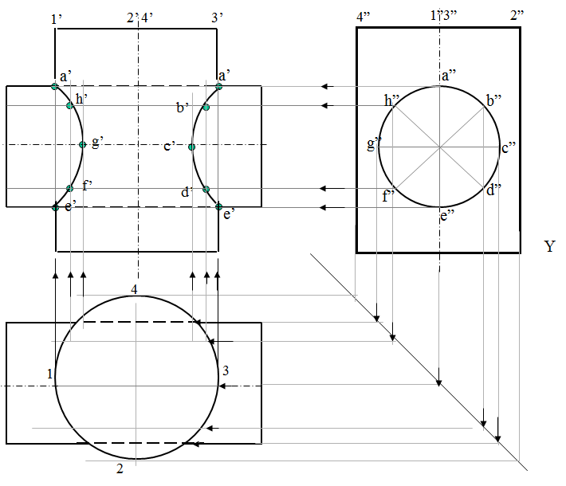

1. A vertical cone, base diameter 75 mm and axis 100 mm long, is completely penetrated by a cylinder of 45 mm diameter. The axis of the cylinder is parallel to Hp and Vp and intersects axis of the cone at a point 28 mm above the base. Draw projections showing curves of intersection.

